JAVA & JENKINS VERSION VERIFICATION:-

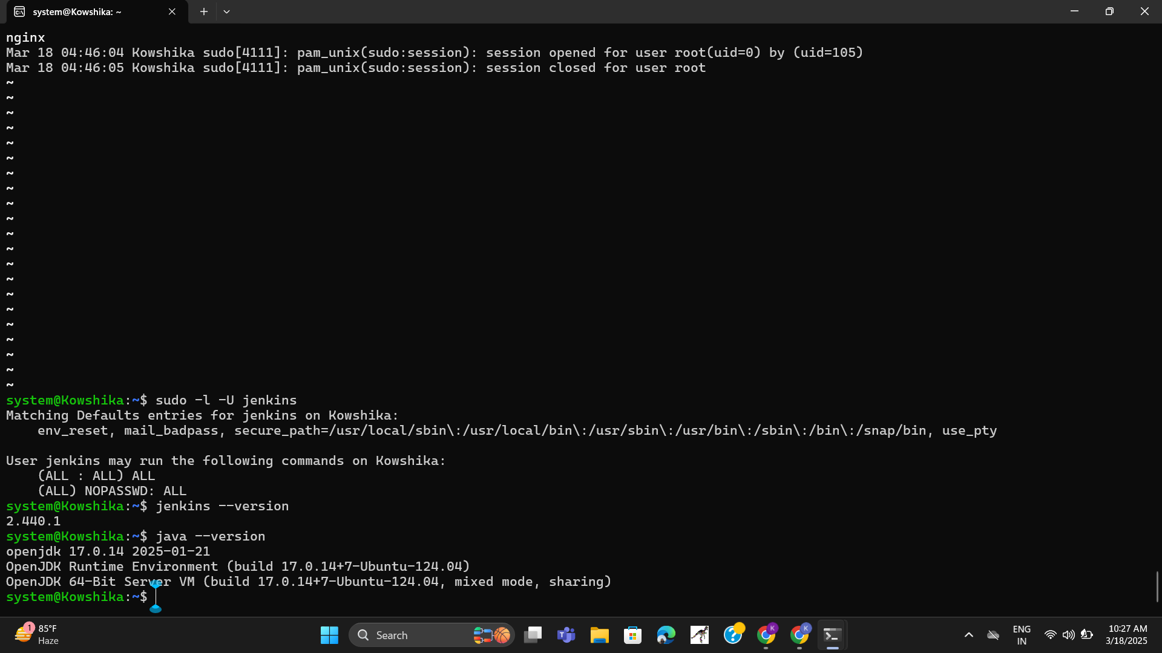

IPADDRESS VALIDATION PAGE:-

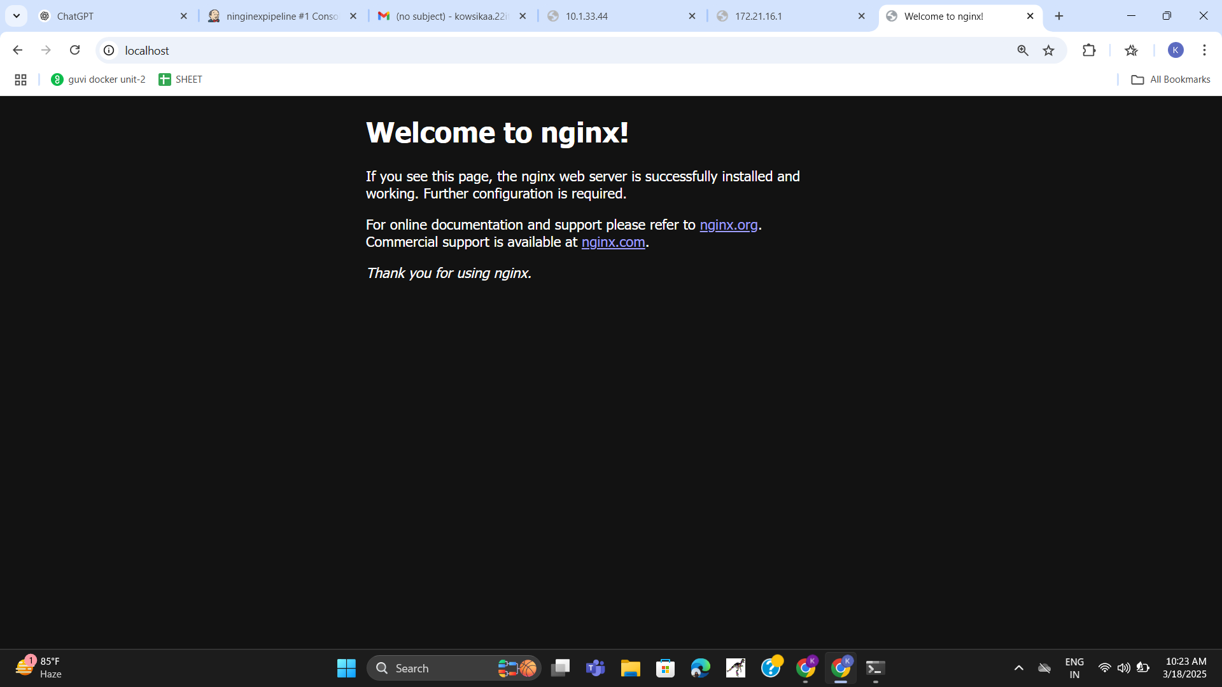

BUILD SUCCESS PAGE:-

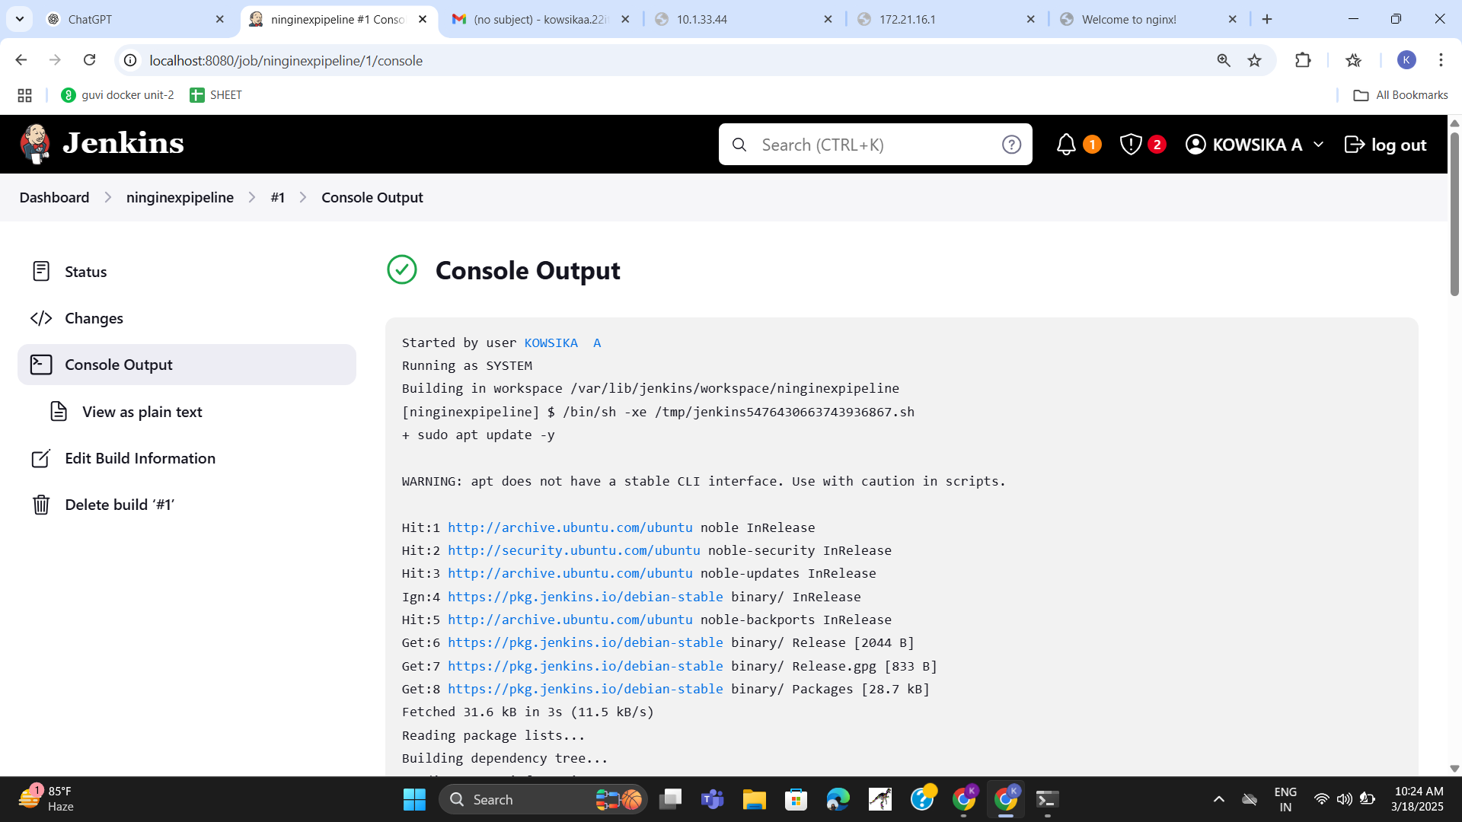

JENKINS SERVICE PAGE:-

